Design a futuristic submarine

Submarines have been the inspiration for many, from scientists, authors and artists throughout time.
One of the most famous stories was ‘20,000 Leagues under the sea’, written by Jules Vern was published in 1870. Submarines have evolved over time from simple submersibles to nuclear-powered super weapons. They have also been developed for marine research and for salvaging in the deepest parts of the ocean.
As technology and engineering improves, anything is possible for the future designs of submarines.

Create a Submarine:
Design a submarine that marine scientists could use in the future. The design should include the outside features as well as a detailed side profile of what the vessel would look like inside.

Materials:
Paper / card / Pencil and Colouring materials
The pictures below show the design of John Phillip Holland first submarine Holland I.
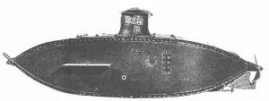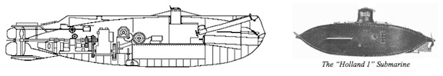

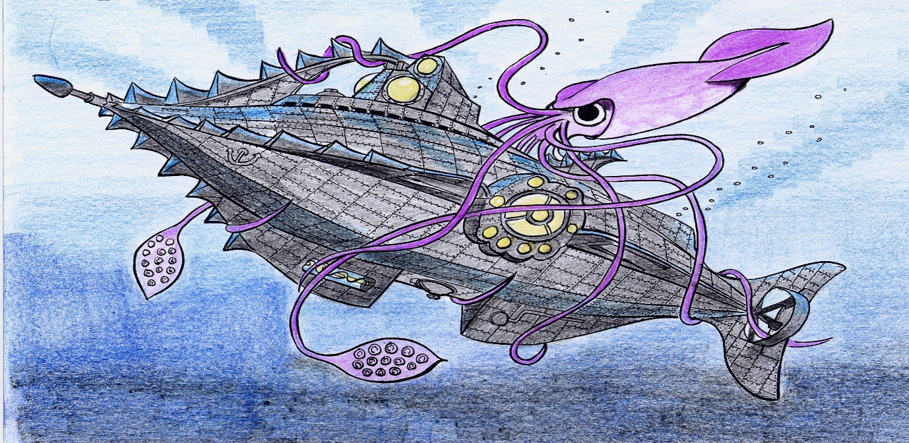

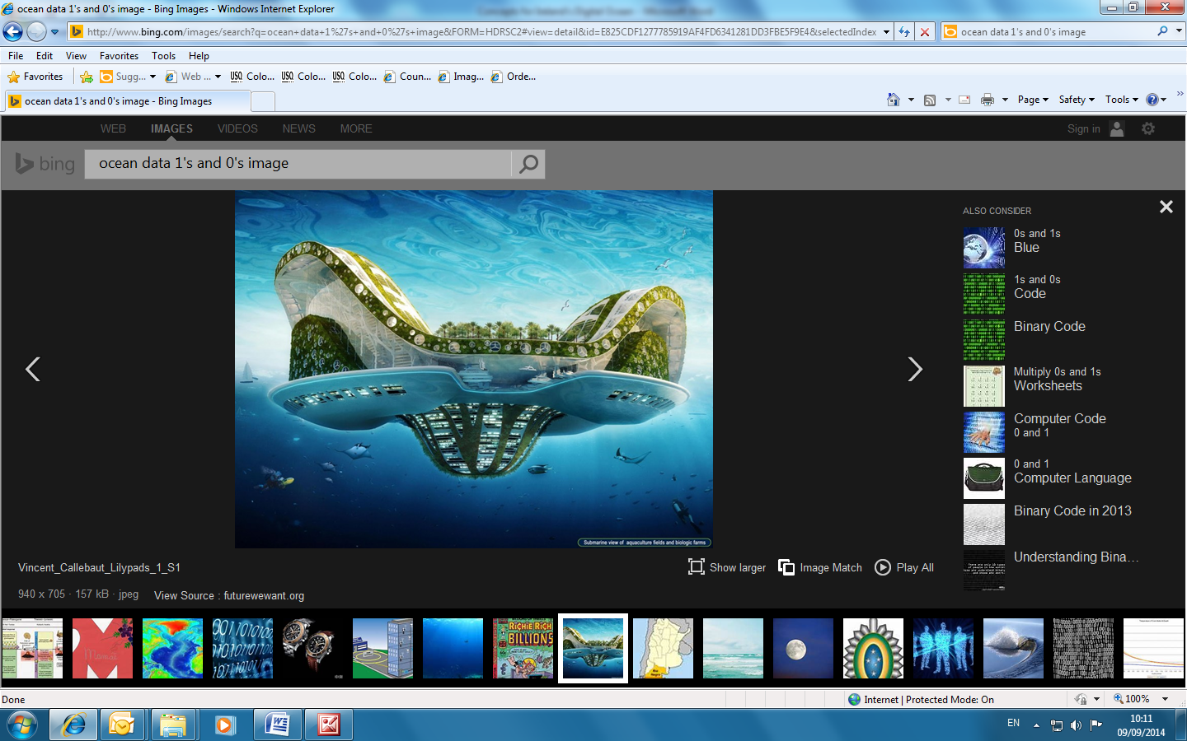

Image by John Joyce, 2006

Maybe your submarine
could be attached to an
island above?

A submarine inspired by
the story ‘20,000 Leagues
under the sea’,
written by Jules Vern

